**Driver Split Duty**

***Work-flow to Use Driver Duty Work Time***

The Driver Split Duty preference is accessed through **Load Template** and only one instance of it is permitted.

***Preference Overview***

This preference sets basic driver split duty parameters for the schedule. It includes the minimum break eligible to be defined as a split, the minimum required work time at either end of a split and the largest distance a driver may travel during a split break to the start point of his next trip.

***Templates Available from Optibus***

***Split Duty***

**Purpose:**

As stated in the Overview **Prerequisites:** None. **Opening Dialog:**

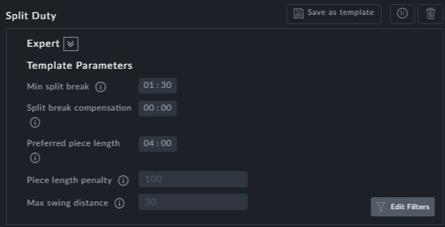

**Points to note:**

**Min split break**: The minimum break length that can be considered a split break



**Split break compensation**: Driver compensation as an hourly wage for split break time for which he is otherwise, not fully paid



**Preferred piece length**: A piece is the preferred (minimum) work time at either end of the split break



**Piece length penalty**: This is the maximum penalty that is incurred if either piece length is too small. The actual penalty is proportional to the violation subject to this maximum. For example, for a **Preferred piece length** of four hours, and an actual piec length of 3 hours, the penalty is (4 - 3) / 4 * 50 = 12.5. It increases proportionally as the actual piece lengthdecreases.



**Max swing distance**: This is the maximum allowable distance a driver may travel between a split start and split end. For example, a driver completes the first part of his duty before a split break. During the split break he is required to travel to a dif- ferent location to commence the second part of his duty. The distance he travels may not exceed the **Max swing distance**.



**Edit Filters** should not be used with this template.